Project Planning Phase

Date | 19/02/2026
Team ID | LTVIP2026TMIDS66407
Project Name | AUTOMATIC CAR CATALOG SYSTEM FOR ENHANCED SHOWROOM MANAGEMENT
Maximum Marks | 5Marks

Assigned Task to the Group members as shown in below:
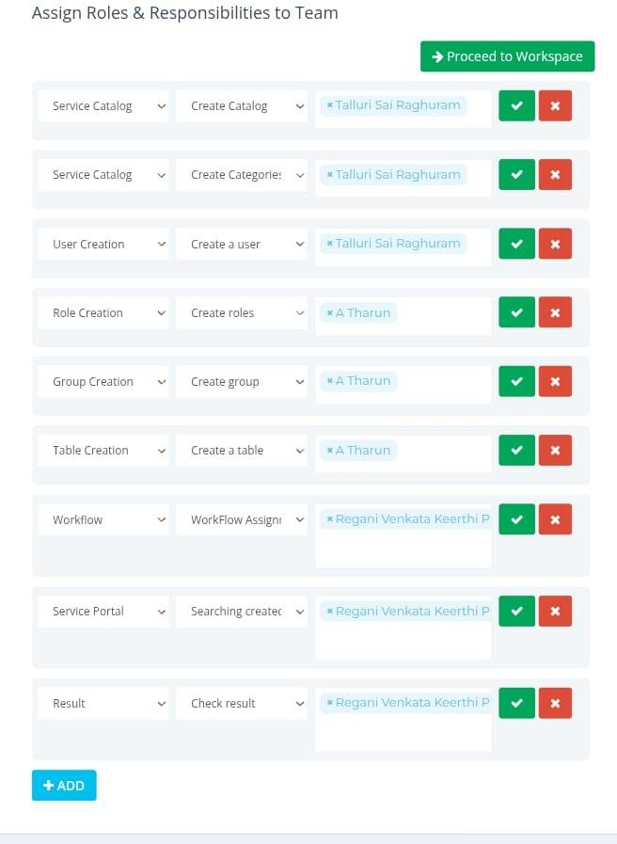

Functional requirement | User story | No of Activity | Team Members
Service catalog | As a user, I want to access an automated car catalog through the ServiceNow Service Catalog so that I can easily view,request,and manage available vehicles in the enhanced  Showroom system. | 1 | Talluri Sai Raghuram
User creation | As a showroom manager, I want to automate user creation for the car catalog system in ServiceNow so that new users can quickly Access and  manage car listings efficiently. | 1 | Talluri Sai Raghuram
Role creation | As a system administrator, I want to create and assign user roles (e.g., Sales Agent, Inventory Manager, Service Technician) in the automated car catalog systems of that each user has appropriate access and permissions for enhanced showroom management in ServiceNow. | 1 | Talluri Sai Raghuram

Group creation | As a showroom manager, I want to create and manage user groups automatically in the Car Catalog System within Service now. | 1 | A Tharun
Table creation | As a showroom manager, I want an automated car catalog table in ServiceNow to efficiently manage and track vehicle inventory, features,and availability for Enhanced showroom  operations. | 1 | A Tharun
Workflow | An automated car catalog system in ServiceNow streamlines enhanced showroom management by enabling seamless vehicle data entry, real-time inventory updates, and automated workflows for approvals, pricing,  And customer inquiries. | 1 | A Tharun
Service portal | As a showroom user, I want to access an automated car catalog through the ServiceNow service portals of that Ican easily browse, compare, and request car models for Efficient showroom  management. | 1 | Regani Venkata Keerthi Priya

Result | . A user can automatically view, manage, and update a real-time car catalog in the showroom using ServiceNow,streamlining inventory  tracking and customer interactions. | 1 | Regani Venkata Keerthi Priya

